**Normals Data and Normals Database Editor**



**Jacques Régnière**

**Rémi Saint-Amant**

**Ariane Béchard**

**2017**

**Natural Resources Canada**

**Canadian Forest Service**

**Laurentian Forestry Centre**

**P.O. Box 10380, Stn. Sainte-Foy**

**Quebec, QC Canada, G1V 4C7**

Table of Contents

1. Normals Database 1

1.1. Introduction 1

1.2. Normals Editor 1

1.2.1. Stations list Dialog 2

1.2.2. Properties Dialog 2

1.2.3. Spread sheet dialog 3

1.2.4. Graphics dialog 3

2. Record structure 4

2.1. Description 4

2.2. Example 5

# Normals Database

## Introduction

In BioSIM, normals are long-term monthly statistics calculated over 30-year Standard Normal Generating Periods (SNGP), the latest being 1981-2010. These statistics apply to each weather station in the database. A Normals Database contains these monthly statistics for a number of stations, along with the spatial coordinates of each station (latitude, longitude and elevation).

## Normals Editor

Normals database can be opened in the Normals Database Editor application.

The Normals Database Editor application can be accessed by selecting [Tools] [Normals Editor…] from the menu bar, or by clicking the Normals Editor Button  on the main window’s toolbar.

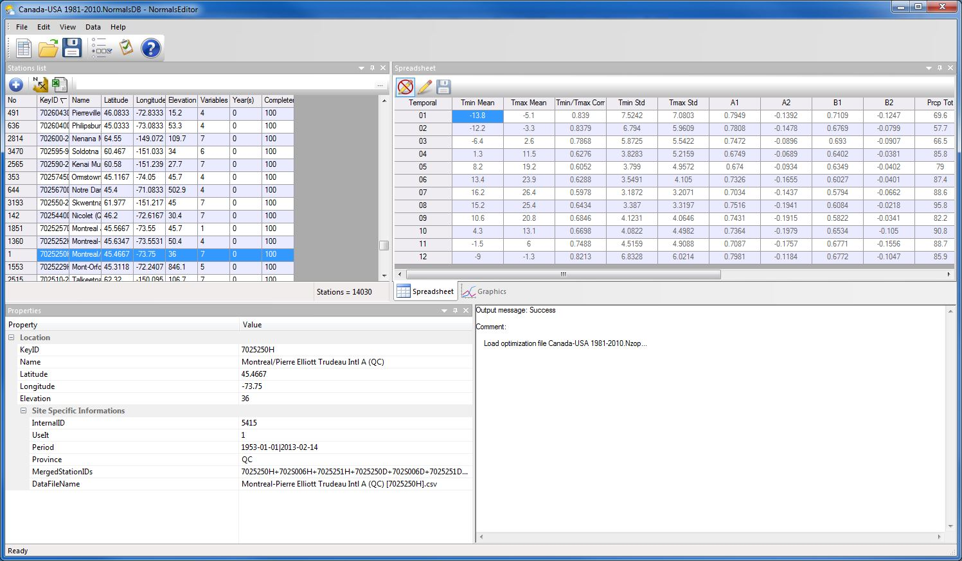

BioSIM’s setup usually creates a link between .Normals files and the Normals Database Editor application (unless the user does not have administrative privileges when BioSIM is first installed on a computer).

The Normals Editor consists of four window: Stations list, Properties, Speradsheet, and Graphics.

Buttons available in the Normals Editor application are as follows:

The New button  can be used to create a new Normals database.

The Open button  in this field can be used to browse for and open database in the Normals Editor.

The Save button  can be used to save the changes on the active database.

### Stations list Dialog

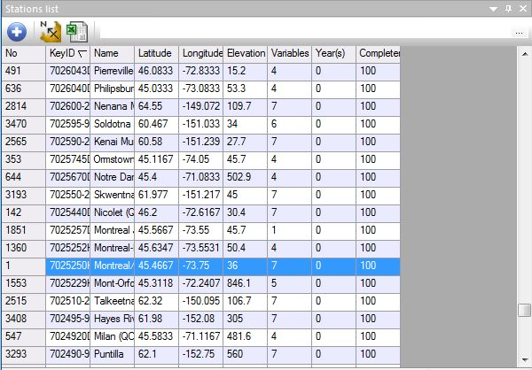This window allows you to view all weather stations in the database and allows adding new stations.

This window offers the following buttons:

 Add: Add a new station to the list of stations in the database

 Send to ShowMap: Display the location of all the stations listed in the database in the ShowMap application.

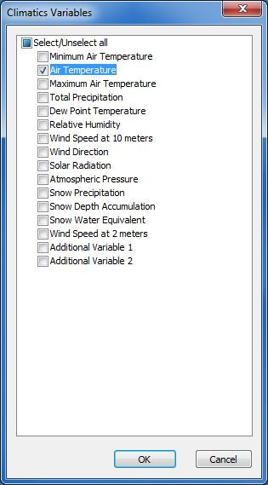Send to Excel: Sends the coordinates of all the stations listed in the database to the spreadsheet software Excel the user previously specified in the *Links* page of the Options dialog.

**Variable filter** field (browse button …)**:** Select filters to apply to the list of stations. You can choose from several Climatic variables.

If all filters are unchecked Décocher, every station available in the database will be displayed in the list field. If two or more filters are checked Cocher, only the stations that have information on each data type selected will be displayed in the list field.

### Properties Dialog

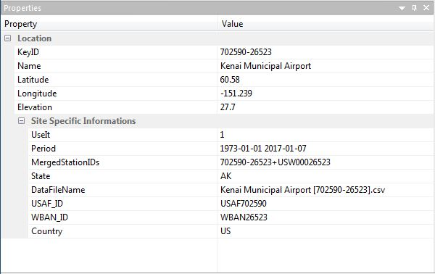This window allows viewing the properties of the selected weather station such as the location (CleNo, Name, Latitude, Longitude, and Elevation), Besides the Site Specific Information (UseIt, Period, MergedStationIDs, State…).

### Spreadsheet dialog

This dialog allows to display by using the Visualisation Mode button  or to modify the data about a weather station by using the Edit Mode button.

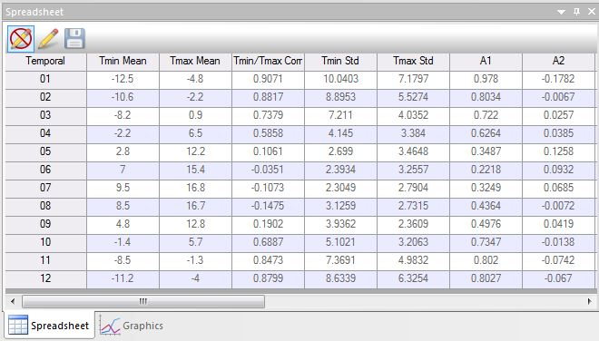

Buttons in this dialog are as follows:

Visualisation Mode  button: allow just visualizing the weather data of the selected station player, either to save modification and seesaw in the mode visualization.

This Edit Mode button  used to activate modify data on a weather station. All fields in the Normals Station Editor are editable.

Save weather data  button: save the modifications, without seesaw in the mode visualization.

### Graphics dialog

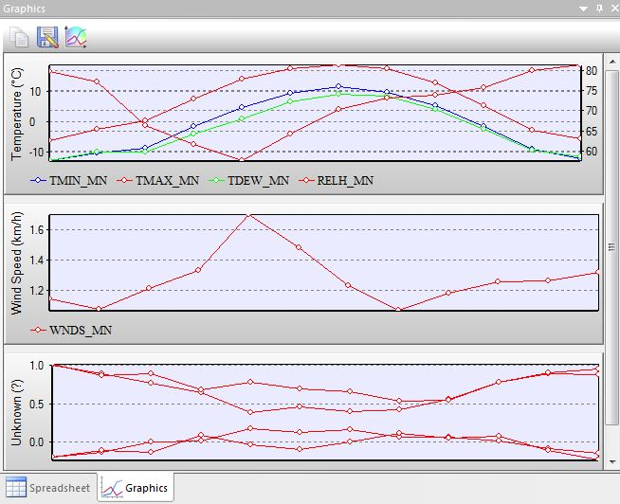This Graphics dialog, which allows the user to view a graph of the station’s weather data (one graph for each type of weather data).

Buttons in this dialog are as follows:

Copy Graphics  button: Use to copy the graphics in press-paper for uses it later.

Save Graphics  button: Use to save the graphs of the station selected in the 'JPEG' images.

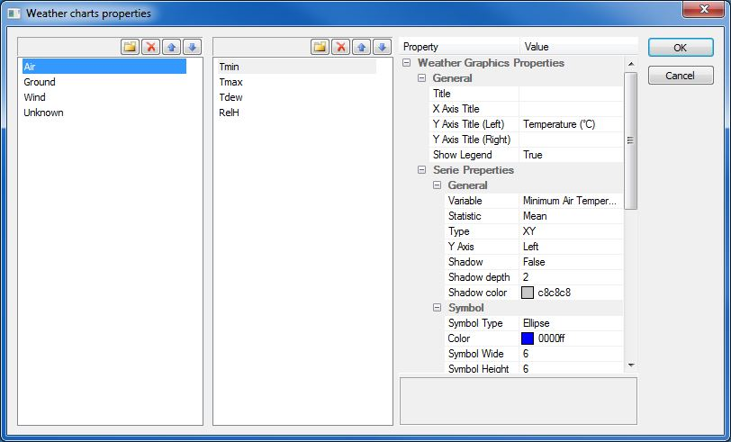Define Graphics Options  button: Used to define climatic variables and the various graphic options.

# Record structure

Record structure of the Normals Database

## Description

The first line in the .Normals file contains the creation date (Year, Month, and Day) of the Normals Database, the first and the last year of data in summarizes, and the format-version of the database. The second line contains the header fields of the weather variables.

Then come the data themselves. Each station’s record consists of 16 lines in the .Normals file.

1: Weather station name

2: Georeference (latitude, longitude, elevation and use-switch (0: no; 1: yes))

3: Contains Temperatures (No: 0; Yes: 1)

Contains Precipitation (No: 0; Yes: 1)

Contains Humidity (No: 0; Yes: 1)

Contains Wind Speed (No: 0; Yes: 1)

Three other switches are present for later definition

4: Weather station ID

5-16: 12 months of data compiled over a standard period of 30 years. A minimum of 10 years of data within the SNGP must be available for a station to be included in a Normals database. Each line of data is comprised of 16 variables:

* Monthly mean minima (Tmin)
* Monthly mean maxima (Tmax)

From these, normal daily minimum and maximum temperatures are obtained by linear interpolation between the means of successive months adjusted to correspond to the values occurring at mid-month. Seven additional monthly normals are calculated from the differences between observed daily minimum and maximum temperatures and these daily normals:

* Cross-correlation between daily minima and maxima (R Tmin/Tmax)
* Standard deviations of minima (Delta)
* Standard deviations of maxima (Epsilon)
* 1st order autoregressive term for minima (A1)
* 2nd order autoregressive term for minima (A2)
* 1st order autoregressive term for maxima (B1)
* 2nd order autoregressive term for maxima (B2)

Two values describe monthly precipitation:

* Average monthly total precipitation (Tot Ppt)
* Coefficient of variation of monthly precipitation (CV Ppt)

Three values describe monthly humidity:

* Monthly mean dew point (Tdew)
* Monthly mean relative humidity (RH)
* Standard deviation of relative humidity (RH SD)

Finally, two values describe monthly wind speed:

* Monthly mean logarithm of wind speed (in Km/h) (Wind Speed)
* Standard deviation of the wind speed logarithm (Wind Speed SD)

## Example

2011 2 28 1981 2010 6

TMIN_MN TMAX_MN TMNMX_R DEL_STD EPS_STD TACF_A1 TACF_A2 TACF_B1 TACF_B2 PRCP_TT PRCP_SD TDEW_MN RELH_MN RELH_SD WNDS_MN WNDS_SD

PUEBLO MEM AP(CO)

38.2900000000 -104.4983333333 1438 1

1 1 1 1 0 0 0

WBAN93058+COOP056740+USC00056740+US1COPU0037

-9.9 8.6 0.5560 5.4282 7.6906 0.6383 -0.0646 0.6064 -0.0093 8.9 0.738 -9.1 58.9 14.781 2.324 0.534

-7.9 10.5 0.5106 5.4375 7.7943 0.6949 -0.0600 0.6274 0.0236 7.6 1.084 -8.2 57.1 15.586 2.433 0.474

-3.4 15.3 0.3350 4.3169 7.0903 0.5588 0.0306 0.6603 -0.1337 23.6 0.686 -5.5 53.2 15.247 2.596 0.444

1.2 19.8 0.3670 3.8061 6.8348 0.5242 0.0469 0.6271 -0.1447 35.6 0.890 -2.4 50.6 15.416 2.733 0.407

6.9 25.1 0.2892 3.2318 5.6561 0.5070 0.0557 0.5995 -0.1083 38.5 0.604 3.6 52.3 14.118 2.687 0.344

11.7 30.9 0.2053 2.8328 4.8198 0.4349 0.0863 0.5923 -0.0916 34.5 0.680 7.4 50.1 13.272 2.658 0.296

15.0 34.1 0.1653 2.4955 3.9270 0.4645 0.1350 0.6539 -0.0876 52.3 0.703 10.4 50.2 12.153 2.598 0.258

14.3 32.1 0.1134 2.3980 4.0041 0.5154 0.0717 0.5978 -0.0720 60.7 0.483 11.2 55.2 11.349 2.516 0.265

8.9 27.8 0.2743 3.3493 5.4432 0.5511 0.0486 0.5193 -0.0074 19.6 0.771 5.5 52.4 12.889 2.487 0.319

1.3 21.0 0.2640 3.8316 6.4219 0.5642 -0.0342 0.5203 -0.0657 18.3 0.967 -1.0 52.4 14.656 2.448 0.398

-5.3 13.6 0.4335 4.4358 7.3455 0.6361 -0.0652 0.5442 0.0437 11.8 1.190 -6.0 56.0 15.720 2.321 0.520

-9.8 8.0 0.5764 5.5309 7.7999 0.6981 -0.0719 0.6196 -0.0028 9.6 0.643 -8.9 59.8 14.306 2.276 0.517